Brand Color Direction

A Creative Home For Children's Stories
The brand should feel like a place where authors bring their stories and a creative team helps shape them into professional children's books.
The visual direction:
- Playful
- Warm
- Creative
- Professional
- Trustworthy
Color Strategy
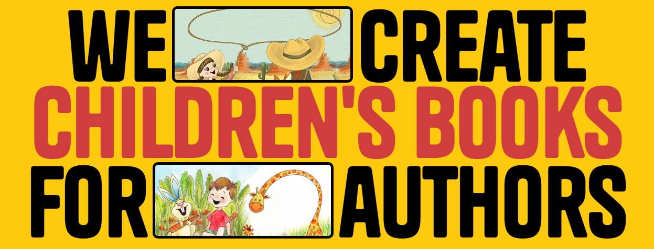


Primary Color: Red
Red creates:
- Energy
- Emotion
- Attention
- Confidence
Use it for:
- CTA buttons
- Important sections
- Highlights
- Brand marks
Do not make the entire website red because it can become aggressive.

Secondary Color 1: Yellow
Yellow represents:
- Happiness
- Childhood
- Creativity
- Imagination
Use it for:
- Background sections
- Icons
- Illustration highlights
- Small design elements

Secondary Color 2: White
This should be the main background.
Why?
Children's illustrations already contain many colors.
A clean white background lets:
- Characters stand out
- Portfolio look premium
- Website feel professional

Secondary Color 3: Black
Use for:
- Text
- Headlines
- Navigation
- Professional sections
Black balances the playful colors.
Recommended Color Ratio
Do not use equal amounts.
Use:
- White: 60%
- Black: 20%
- Yellow: 15%
- Red: 5%
Red and yellow are powerful. Too much will make it look like a fast food brand.

Our website will going to have 6 Main Pages!!
- Home
- About Us
- Services
- Portfolio
- Free Sample
- Contact

